How to embed Qstarz logo into Dashware software

- Download Qstarz logo from Qstarz website: http://racing.qstarz.com/Download/Qstarz%20Logo.dashware

- Double-Click on Qstarz Logo.dashware icon


- Dashware will automatically open a “New Gauge” window, click “Add” to add Qstarz logo into Dashware Gauge Toolbox.
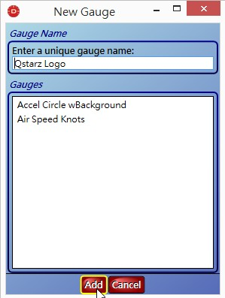

- After successfully added, Qstarz logo will be store in” Gauge Toolbox” , you can use mouse to drag Qstarz logo to overlay on the video.
